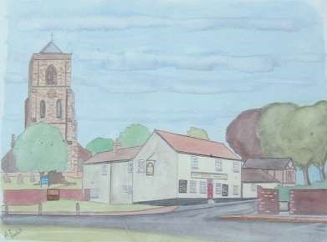

The Newsletter for Middleton on the Wolds

Issue No 24

MARCH

2021

thanks
Many thanks to the Good Samaritans of Middleton on the Wolds who dug and pushed an OAP out of the snow on Saturday 13th February after her car had been run off the road by another vehicle.
It’s good to know that a lot of people still do care about others. Sheelah Bamford
NEXT COPY DATE
14th March

We were delighted to receive the copy of Arthur’s painting of Middleton which I have put on the cover of this month’s Messenger. It is always difficult finding a picture for the front and contributions from budding artists and photographers will be very welcome.
Of course, without your contributions of articles, stories and advertisements there wouldn’t be a magazine at all - so keep them coming.
Please send in your contributions to middletonflyer@yahoo.com by the end of the copy day. If I don’t acknowledge them please get in touch to make sure they have arrived.

Lyn
4 The Paddocks 219500

PICTURE ON THE FRONT COVER
Thank you to Arthur Conduit for his painting of
Middleton on the Wolds

editorial
At the time of writing the village is still covered in snow, which is fine on the fields and gardens, but less so on the roads and pavements. The gritters cover the four roads into and out of the village but it’s up to us to deal with the rest. So a big thank you to all those who have cleared the snow from in front of their
homes; it makes it much easier to get around and, when the thaw finally comes, it will make walking in the village a lot less messy!

On the other hand – it’s been snowing! Everything looks better covered in snow, more so when the sun is shining, and it has made walking the dog even more entertaining (especially when she loses her footing and looks up nonplussed as if to say; ‘Who put that there?’). A combination of snow and sun also means snowmen and tobogganing. We live in the Wolds and (the clue is in the name) there are plenty of slopes to ride a sledge down and we must thank the farmers who allow us to play on their land.

By the time you read this there should have been an announcement on changes to lockdown measures. The existing restrictions have been at best inconvenient and, at worst, have caused real financial hardship but they do seem to have been working. Infection rates have fallen steadily since Christmas and this is leading to fewer admissions to hospital and, thank heavens, a fall in the numbers dying each day from COVID 19. But we had the same situation at the end of the last lockdown when the relaxation of restrictions was followed pretty sharply by a rapid increase in the rate of infection. So let’s not go mad, eh? Just because you may be able to go out doesn’t mean you have to. If you have to go out remember to keep your distance, wear a mask, and keep washing your hands. If you’ve already had your vaccination, well done. If you’re not sure about having it remember that it’s not just going to protect you, it will also help protect everybody else. We got rid of smallpox through a global vaccination programme and we can do the same to COVID.
Stay safe.
Mike

If you have any ideas, comments or complaints (especially complaints) you want to share then send an email to middletonflyer@yahoo.com.
Remember, we can’t respond unless we receive your message.
letters
The following suggestion was sent into The Messenger by Geoff
Cox
Middleton Olympics and Gala day
Something for all regardless of age and ability.
A concept and a proposal for a fightback (after this last year) - to show that we are still active and care about our community.
A Middleton Sports and Gala day to be held on a Saturday in August - centred on the Playing fields.
Including Cake, Flower, Photography and Fancy Dress competitions. Beer tent if allowed.
11am - The ‘Middleton Olympics and Gala day’ will be officially ‘opened’ at the Playing fields.
Iron Man and Iron Woman - 5K races. A limit of perhaps 50 runners. All runners preregistered and supplied with a unique running number bib for attaching to their running vest.
Note – Volunteer Marshalls are to be posted at all road junctions and corners on the circuit (Hi-Viz jackets and mobile phones required).
Route -
Starting at the Playing field the race will commence with a circuit of the Playing fields and then exit through the wooden gate on to the railway embankment pathway and then along and down on to Station Road. The route then leads over the zebra crossing onto
South Street, up the hill and left onto the ‘field’ pathway towards Goodmanham Road. The pathway will need some prior work levelling the ground and cutting back the branches. Then the race proceeds either through the wood (permission required) or up Goodmanham road using the grass verge. The verge may need a grass cutter running over it and some degree of levelling beforehand.
Then turning left through the wooden gate and using the existing path at the top of the woods onto Beverley Road. Turning left and using the grass verge down to the village and back across the zebra crossing to the railway embankment path and on to the Playing fields. Medals for the winner in both races together with the titles of “Middleton Iron Man” and “Middleton Iron Woman”.
11am - While the above race is in progress, junior versions can be run on the playing fields – eg twice round the field including using selected existing playing field apparatus.

12 Noon - 5 aside football competition – Adult, Junior, Child. T-shirts supplied to all the football competitors with unique team colours (Red, Blue, White, Green etc).

A logo for the football shirts, medals and running bibs to be designed in a competition held at the school.

Other competitions to be held from 1pm onwards – Adult, Junior, Child:-

Great British Bake Off - best decorated sponge cake – marquee tent.
Great British Sewing Bee - Crochet, Knitting, Embroidery competitions – marquee tent.
Best Fancy dress - marquee tent.
Best Flower display in a 15inch hanging basket – marquee tent.
Best Photo of the Village (6x4).
“Best in Show” – Dog competition all classes included (held on the ‘all weather’ Tennis court).

The highest score in each case to win a medal. ‘Knockout ‘rounds if required.
Beat the Goalie using 10 penalty kicks.
Bat the Ball in the bucket competition from 20 balls (using the cricket nets and tennis balls).
Nearest the Jack from 10 bowls each - (indoor and outdoor bowls).
Tennis knockout competition.
Highest darts score from 9 darts (inside the Pavilion).
Archery competition – best score from 10 arrows.
Exhibitions – eg Birds of Prey exhibition (South Cave?)

Fund raising – Sponsorship.
Requirements – Managing committee, Marquee tent, Refreshment tent, Programmes, Bunting, Balloons, Start /Finish line, Toilets, Signs, Permissions, Sports equipment, Marshalls etc.
Finally
This is just a very basic outline of what could be done but it will need a lot of volunteers and even more organisation.
Initially, if interested in helping with this could you please contact me at geoff_c_cox@hotmail.com

Geoff Cox
Hi Geoff,

This is a brilliant idea! A day like this would be of interest to and involve most of our residents but, as you say, would also entail a good deal of organisation.

Hi Mike

Hope you are keeping well through these unusual times. Glad to
see my path is standing the test of times. Didn
’
t think the top
dressing would hold but it seems to be up to now.

Saw this on line and thought if the village is still having problems with dogs
this might be a possible poster to use...may have to alter the odd word so as
not to offend the few...haha.

Steve R

Mike

Admirable sentiments, Steve. Let's hope people take notice - especially when crossing the Rec, or so I've been told!

Thanks,

Mike
Please be aware of the dognapping that is going on in this area. It has been reported that people in white vans have snatched dogs from their owners while out walking and they are now using vans with RSPCA painted on the side and saying they need to take your dog.
Do not hand your dog to anyone.

QUIZ PAGE
- What is the Middle Name of Donald Duck?
- In which city is the Sacre Coeur?
- Who had a hit with Lazy Sunday in 1968?
- A ‘Sloppy Joe’ is an informal name for which item of clothing?
What was the name of the flagship used by the English fleet against the Spanish 5 Armada?
- Which Band was On the Run in the 1970's?
- The 1918 pandemic was given what name?
- Carisbrooke Castle is on which island of the U.K?
- What was Billy Butlin famous for?
Russian operative Sergei Skripal and his daughter were poisoned in which 10
Quiz set by Rowland Wooldridge

DINGBATS of BRITISH TOWNS SUDOKU
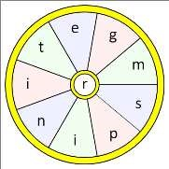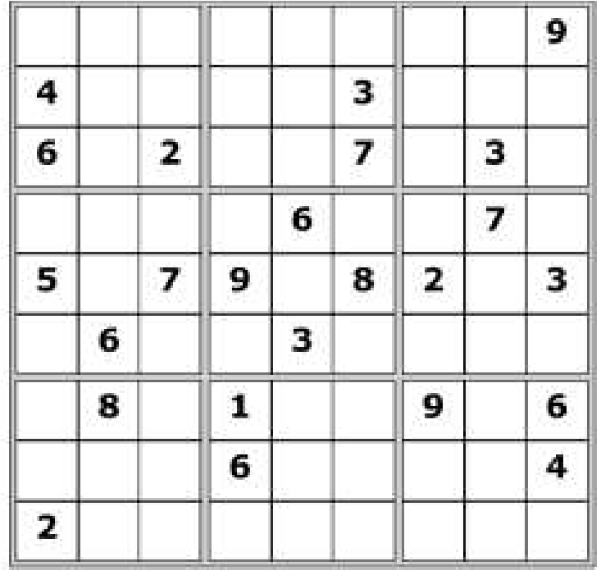
All answers on page 20

SEASONAL WORD WHEEL

Try and find the full word, then make
as many words of any length as you
can from these letters. You can only
use each letter once, and each word
must include the letter

R
.

LOCAL HISTORY
SCHOOLDAYS – APPROACHING MODERNITY
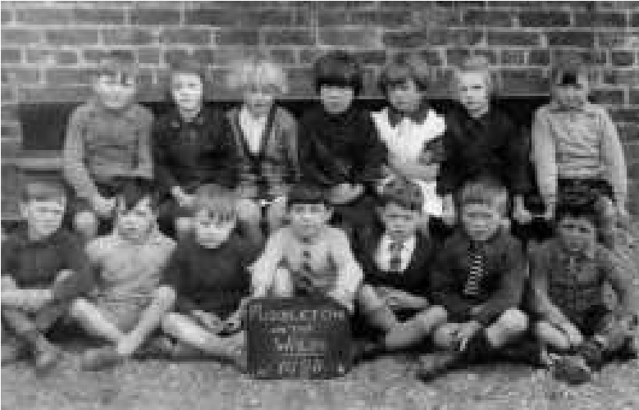
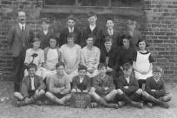
The postwar period started with a new headmaster, William Clark Godson, his predecessor having taken charge of Wallingfen school.
Classes of 1928

The familiar problems persisted in Middleton with regard to health, harsh winters and staff changes while any progress in teaching reflected in inspection reports appeared patchy. Armistice and Empire Days were observed, the former with “O God our help in ages past” and the latter with patriotic songs and the saluting of the Union Flag. Holidays were still granted for
Jack Bentley is front row, 2nd from right the Middleton Feast and the
periodic visits of the hounds to the Hall but there was however less involvement by the Rector and the occupiers of the Hall which was itself a reflection of the growing erosion of the old village hierarchy. Poor heating, a long standing problem, was tackled in September 1930 by removing the open fireplaces and the installation of a stove with radiators plus a water tank and new taps. Medical and dental inspections continued.
The Church Authority inspections gave favourable verdicts on the school but the County Council’s inspectors were not impressed and during a visit in 1921 stated “The managers of this school, I am told are very indifferent – the buildings show signs of the correctness of this information.” The report continues “One cannot help noticing the similarity between the children of Middleton and those of Lund and South Dalton – rough, stodgy, untidy and uncouth. It leads one to think that these characteristics belong to the district.” However class photographs of the time do not paint too bad a picture of the pupils at that less than affluent period between the wars.
Throughout the decade and into the next inspectors had a problem with the headmaster who was considered a weak and unattractive personality, humourless and with an exaggerated sense of his own abilities. However from time to time they acknowledged his efforts to improve the school, bring it up to date and conceded he meant well. More positively another report stated “The teaching of infants is very satisfactory, Miss Dowson being a teacher of outstanding ability and personality. Her manner with children calls for admiration.”
By 1932 the library van was calling at the school and in March 1935 there was another sign of the times when Mr Gibson, BBC Director of Studies for the North of England, gave the school interesting facts about “Broadcasting Lessons”. Mr Godson’s death in 1934 was followed by 3 brief headships until 1936 when Stanley Hogarth, the new and longest serving headmaster, arrived remaining in post until 1960. In this period the academically gifted were given the opportunity to gain scholarships and in July 1935 Watson Stuart obtained one. In that year the new village hall opened which provided facilities for events hitherto held at the school.

On a personal note Percy Linford (1914 – 1997), who liked Mr Godson, started school aged 3 and recalled years later the strict discipline and the then headmaster’s fondness for release from school at the end of the day being dependent on the solution of a mental arithmetic problem. He also remenbered that children from outlying areas who brought a sandwich for lunch had to obtain a drink from nearby houses. Earth toilets were used and the waste buried in gardens. No talking was allowed in class and infringement of the rule could result in a caning.
Football and cricket were played by the boys in the playground (no field) while the girls played rounders and skipped for which most girls regularly carried a rope. The staff consisted of the headmaster and 3 teachers with a female caretaker who came in after school.
Jack Bentley remembered that during his time at school in the twenties and thirties the conflict between the need for education and the parents’ desire to have their children at work, so persistent in the early days of compulsory schooling, had largely ceased: education had won.
Geoff Wisher

St Andrew’S church

Sadly, until the Covid 19 situation improves the Church remains closed except for private prayer,by appointment.

We very much hope we can reopen in time for Easter services.

A note from your vicar
Lencten Fasten and Badger Peas

The word ‘Lent’ comes from the Old English word for Spring, ‘Lencten’, and was originally the ‘Lencten Fasten’, the Spring Fast. Today we may give up some minor calorific indulgence but in years gone by it was a time of serious fasting and intense devotion.
Lent lasts for 40 days – not including Sundays, and is held by the church to be a time of prayer, fasting and repentance. And is a reminder of the 40 days Jesus spent in the desert when he was wrestling with the form his ministry would take. Today this time can be seen as an opportunity to reflect on the way we live our lives, the choices and the contribution we make to the lives of others and our world. This year people are being encouraged, if able, to donate 40 items to the local Food Bank, or 40 items to a charity shop (when they reopen) whilst not replacing those items with more ’stuff’ !
In the North of England, the fifth Sunday of Lent – Passion Sunday was known as Carling Sunday. Carling is thought to derive from the word for Care, sorrow or grief and marked the beginning of Care Week, a solemn time in the church year when the suffering and death of Jesus is remembered.
In ancient times pulses symbolised immortality and were often eaten after Roman funerals. In Cumberland, the Scottish Borders and down to the
Humber, Passion Sunday was traditionally marked by consuming Carling Peas, they were served in pubs where a ‘carling groat’ would be spent on ale and free peas were provided by the Landlord. These little pulses, also known as Badger, Black and Pidgeon Peas seem to have gone out of favour in recent times.
When the travelling fair (or ‘Wakes’) came to Leigh, there was always a large Bell Tent which we visited as soon as we arrived to buy Black ‘Peys’ (peas) which had been boiled up in a large dixy pan, they were always cooked and served with malt vinegar – just the thing to warm you up on a cold winters evening.
Old Lenten recipes are not very inspiring, however, on Mothering Sunday also known as Refreshment Sunday, it was an opportunity to have a break from fasting and Simnel Cake would be served – now it is seen more as an Easter Sunday treat.
Jane

Village hall news
Thank you to those who took the time to complete the recent Village Hall survey. Although there were only just over 50 forms, we have been able to get some idea of how you would like us to proceed with the refurbishment and what you would like to see the hall being used for in the future.

An indoor food market looks to be the most desired activity, closely followed by a cinema evening and a craft afternoon, although there were a number of votes for more quiz nights, music evenings, fitness classes, themed food events and coffee mornings.

A few people pointed out the poor acoustics which we are trying to improve with various grants that have been applied for. We would love to be able to offer better parking but that is, unfortunately, out of our hands. Two people would like a new hall - wouldn’t that be nice? I’m afraid we can only work with what we have.
A quick update on the 100 Club: so far we don’t have enough enquiries to make it feasible so, if you are interested please contact Sharon on 217254 or sroe.general@gmail.com.
We hope the hall will be opening again fairly soon so please bear it in mind when planning a regular class or a one-off event. The hire cost is very reasonable at only £8 per hour (£24 per 4 hrs, £50 per day). To book email lyndennis456@gmail.com or ring 219500.
The Village Hall Committee
MIDDLETON PRODUCE SHOW
This year we’re having a Produce Show with a DIFFERENCE not a show as we know it
WATCH THIS SPACE in future editions of THE MESSENGER

Local Birds & wildlife
I have never gone in for a soap opera style report, let alone leaving on a cliff-hanger, but following straight on from last month’s Pheasant love-pentagon, I am typing this on Valentines Day and … well, sadly nothing to report. The male is looking slightly crestfallen, and the females still visit occasionally and continue to ignore him. Perhaps the snow, still a few inches deep, is putting
them off? This is emphatically not the case with the wood pigeons, two of whom were having – well, shall we call it a tryst? – on the lawn the other day, in sub-zero temperatures.
Meanwhile the garden birds are definitely getting more vocal, and starting to call as soon as dawn begins to break, so spring is out there somewhere!
Going back to the end of last month I was thrilled to hear from Richard of Orchard Drive that “This morning a peregrine falcon flew over the village in a SW direction, at a height of about 150ft.” I know I’ve said before that it’s always worth looking out as you never know what you might see, but I had never dared dream of peregrines!
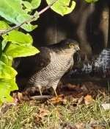
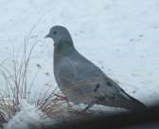
Another bird of prey sighting - and a lovely photo - came from Claire: “On Sunday morning I went out into the garden and saw something shoot past me into the laurel bush at great speed. There was a lot of shouting from the other birds who sit in that bush. What I discovered was a sparrow hawk under the bush plucking the feathers from its prey. It flew off with the other bird in its claws about 10 minutes later, probably to find a quieter spot to enjoy its lunch.”
Hazel found a fierce bird Photo by Claire Giddings chasing all the other birds away from their food in
her garden – it was a stock dove. Forget the dove being a gentle bird of peace, this one was “very dominant”! Luckily she was able to get a photo through the window.
Finally, moving out of the village a bit, Sheila
was excited to see a short-eared owl hunting over Photo by Hazel Kazer fields near Kilnwick. Although other owls do sometimes hunt in the day (barn owls in early dusk for example), this is the only real daytime owl. They are not at all common, but are resident in this general area all year so look out for a large pale owl with dark markings on it’s back and upper chest! She also saw the marsh harrier that she had seen before, and also some deer in the distance, so a good afternoon! Back to Middleton, she has been amused by a “huge” robin feeding from the feeders and, surprisingly, a half-coconut shell, and starlings hanging upside down from the shell in an acrobatic display.
Please let me know what is going on out there, either by text on 0777 192 7868, or email me on lavenderbarbara97@gmail.com Let’s hope spring has arrived by the next newsletter!
Barbara

Middleton book group

February’s books:

White Teeth - Zadie Smith
White Teeth focuses on the lives of two wartime friends - Samad Iqbal and Archie Jones and their families. It is set in North London in the melting pot of people from all over the world and bridges the generations, class and race of post war Britain through their quirky friends and relations. It is a lively and colourful read.

The Fourth Sacrifice - Peter May
Set in modern China, the main protagonists are a Chinese policeman - Li Yan and Margaret Campbell - an American Forensic pathologist, previously romantically linked, brought together to solve a series of horrific murders. Peter May paints a haunting picture of modern China and through the story, tells something of China’s long, varied and fascinating history.

June
}}}

Next books for discussion:
“The Siege” by Helen Dunmore
“The Bronze Horseman” by Paullina Simons

To find out more about the Book Group please contact Lyn on 219500 or lyndennis456@gmail.com
Middleton on the wolds ce ve school
Executive Headteacher: Mrs E Harros
Station Road, Middleton on the Wolds, Driffield YO25 9UQ
E-mail:middleton.primary@eastriding.gov.uk Tel: 01377 217323

Middleton Minis
Following Government guidance, Middleton Minis will not be running for the near future. Once we are allowed to re-open we will inform you via the parish newsletters.

On-going Collections
On-going Collections – We collect used stamps and used batteries. Please note we are not currently collecting used printer cartridges or mobile phones until we can source a new company to collect and recycle them. Thank you.

Middleton on the Wolds Nursery
At Middleton on the Wolds CE (VC) Primary School  Providing education for 2, 3 and 4 year olds Monday - Friday.
 We accept the Government’s childcare vouchers for up to 30 hours of free provision for 3 year olds (conditions apply)
 Additional sessions can be purchased for £13.50 per session for 3 year olds and £15.75 for 2 year olds.
 Lunchtime sessions are £1.75 (free if children attend for the whole day) with the option to purchase a school meal for £2.40.
 Children are welcome in the term after their 3rd birthday for funded places.
For further details please contact: Sharon Stone
Email: middleton.primary@eastriding.gov.uk Tel: 01377 217323

School Dates
We break up for Easter Holidays on 26th March and return 13th April 2021

Parish council
CENSUS DAY - 21st MARCH 2021
Every 10 years the Census gives a complete picture of the Nation.
Census population estimates are vital in helping to shape the communities in which we live and work.
Census statistics:
Underpin policy making and council funding allocation from Central Government.
Provide information to help plan and prioritise service delivery.
Give a benchmark for estimates of population between censuses.
Provide unique detailed demographic information about local small area populations.

Examples of how local authorities use Census Information
Planning and Development
Public Health and Social Care
Education
Transport
Housing
Other - To be able to inform Emergency Services, Library Services and Waste Collection and Disposal
Billions of pounds are allocated to local authorities every year using census information. To ensure a successful census, a return rate of over 94% is needed.
Census 2021 will be mainly online and you will shortly be receiving a letter through the post with an access code that will enable you to login to a secure website to enable you to complete your form on line. If you are unable to use online services a paper version of the questionnaire is available.
Three new questions to reflect the needs of society are being introduced.
Previous UK Armed Forces Service (to help service providers help veterans)
Sexual Orientation
Gender identity,
This information will help organisations deal with inequalities and show where services are needed.
Data protection and privacy - the census asks questions about you, your home and the people who live in it. The information you provide is confidential and nothing is published that will enable you to be identified. The information stored in the census is safe and confidential by law for 100 years.
Linda Jones

THANK YOU

What a strange year 2020 was and the start of 2021, something that we never dreamt of happening, was going into Lockdown and causing many problems for villagers who were housebound had transport difficulties or advised to be isolated. We then showed what a caring number of residents we have with the list that went into the May '20 Messenger offering help with Shopping - Meals - Maintenance or any other problems which they required help with. Friends and neighbours also stepped forward and have done many things including keeping in touch with the housebound with telephone calls and a chat to brighten up their day. Thanks should also go to the person down Godmanham Road who has green groceries for sale.
Below are one or two items which may be interesting and already available to villagers and have been throughout the crisis.

PRESCRIPTIONS

Over 30 years ago when the Doctors Surgery closed in the village a special arrangement was made by the Parish Council with Cranwell Road that a member would collect them each week and with the help of the owners of the Village Shop they could be collected from there. This is a FREE SERVICE and has been run by volunteers ever since. Please remember it' s up to each patient to ensure that they are ordered in time for their due date. If you would like the person who collects the medication to take your request in then please get it to the Post Office TWO THURSDAYS before collection is required.

MEALS

As many Villagers know we have lost many of our Amenities over the past few years and have now been left with only three. We don't want to loose another, so are grateful that the Robin Hood Public House decided to do a TAKE AWAY SERVICE DURING THE CRISIS. They are good value for money in this very difficult time for many Villagers, and also keep staff in employment.
These are available on a Friday-Saturday between 17.00 & 19.00hrs, also on a Sunday Lunch time from Noon - 14.00 hrs. All orders must be made before 20.00hrs the night before. TEL: 01377 217319

Please help to keep another business open for the village.

FOOD CADDY LINERS

The Yorkshire Country Women invite guest speakers to many of their meetings and two years ago had one from East Riding Recycling Waste Watchers. It was arranged by a Parish Councillor after the meeting that Middleton could have these at the Parish Office as it was difficult for some Villagers to get them from the Library. Villagers could call on a Monday between 9.30 - 11.30 at the Parish Council Office at the Reading Room or they could ring 217456 to arrange collection. Due to the present Crisis the Post Office have a limited number or you can call the above number until we are back to normal again.
Our condolences go to all Villagers who have lost loved ones during the past year. It is never easy to cope with such an event and can be even more difficult without the near contact with Family and Friends.

Please remember to keep our Village safe by following the guidance on HANDS - FACE & DISTANCE.

Kath Bentley

ADVERTISING COSTS for the Messenger
Rates Month Year

Whole Page £25 £150

1/2 Page £15 £100

1/3 Page £10 £60
Full colour - Print run 500 copies
Contact: Tina 01377 217242, middletonflyer@yahoo.com
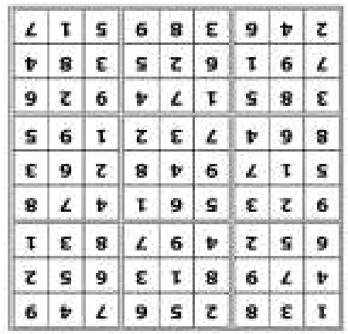
Quiz answers

Dingbats:

Littlehampton

Nottingham

Crew

Ross
-
on
-
Wye

Ludlow

Biggin Hill

Word wheel: Springtime

1

Fauntleroy

2

Paris

3

Small Faces

4

Jumper/sweater

5

Ark Royal

6

Wings

7

Spanish Flu

8

Isle of Wight

9

Holiday Camps

10

Salisbury

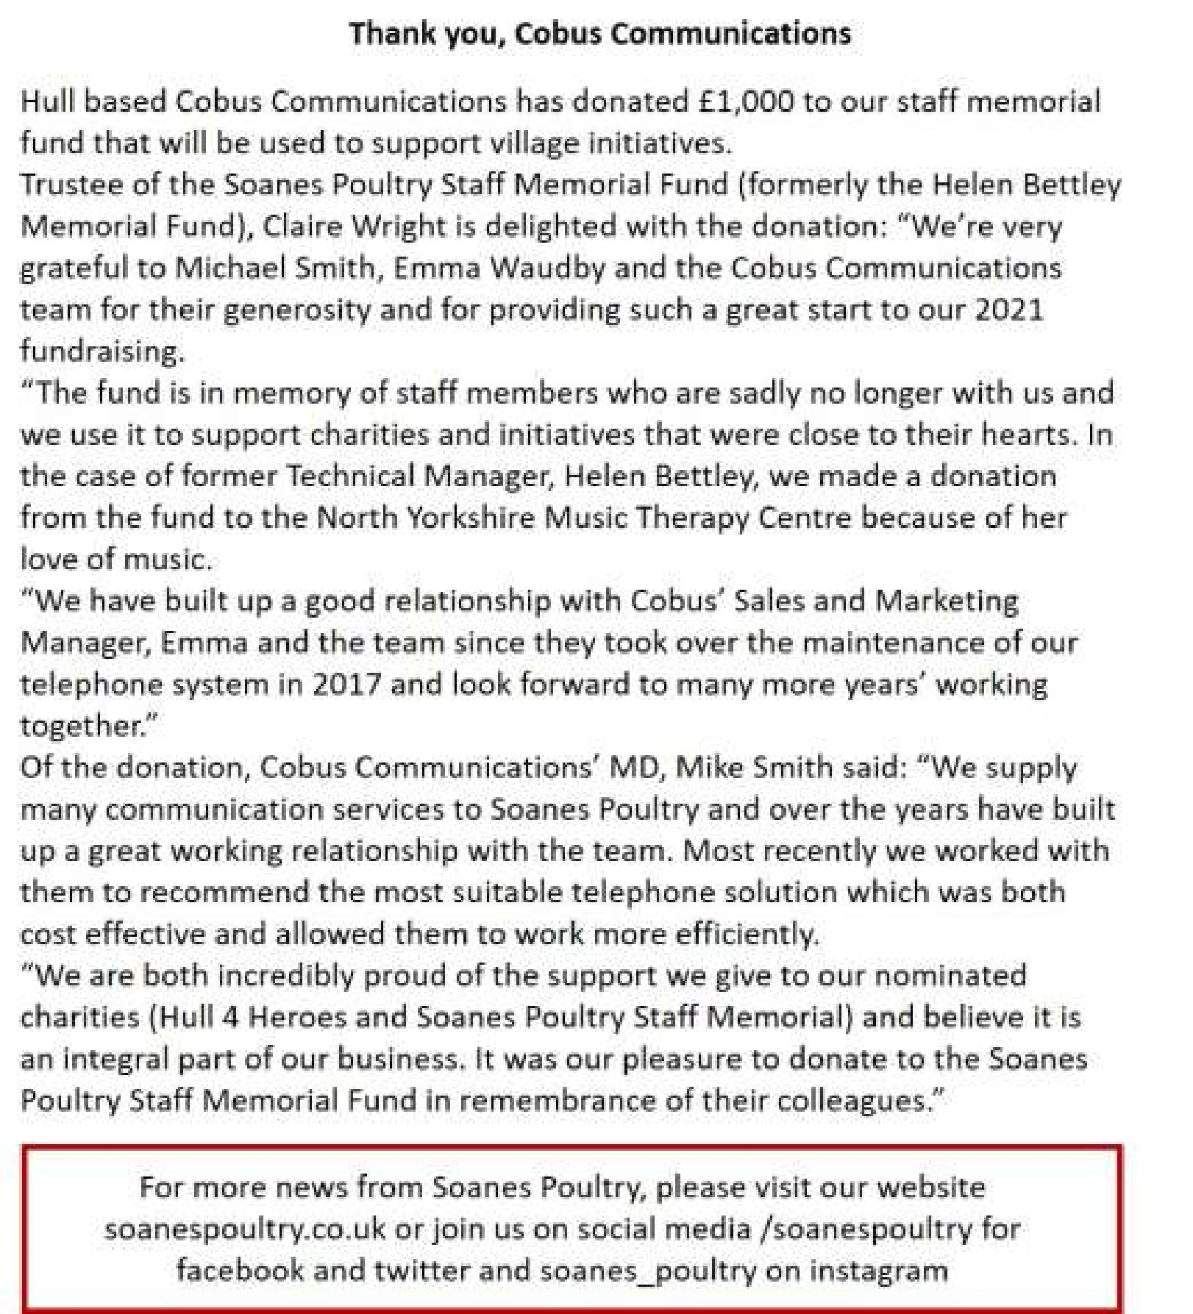
Advertising Feature

Advertisement
Advertising Feature
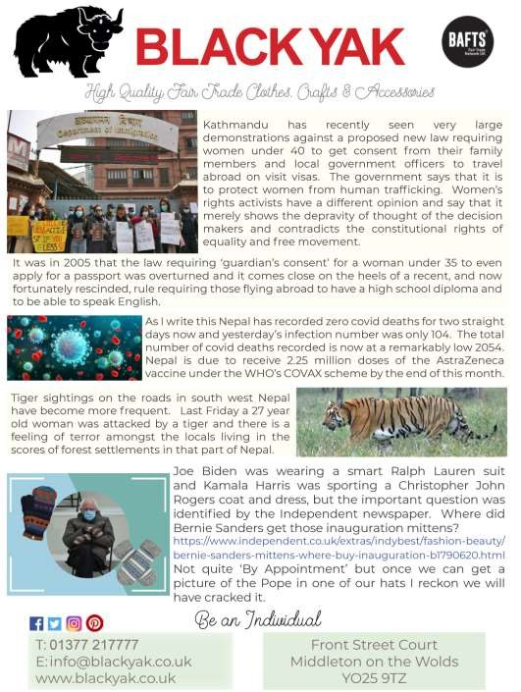
Regular group activities

Weekly Groups
Tuesday YCA 2.00-2.40pm Zoom
Thursday Middleton Movers 2.00-3.00pm Zoom

March
- Parish Council 7.00pm Zoom
- Village Hall Committee 2.30pm Zoom
12 Book Group 2.00pm Zoom
14 Middleton Womblers 10.00am Lime View
(Please check)
25 Yorkshire Countrywomen 7.00pm Zoom

LOCAL CONTACTS Bell Ringing Chris Atkin |  | 217285
Book Group/Middleton Movers | Lyn Dennis | 219500
Bowls Club | Rob Bradley | 217435
Country Women’s Association | Christine Johnson | 217374
First Responders | Chris Brent | 219469
Line Dancing | Pat Pottage | 217516
Methodist Chapel | Jane Gray | 07870 562455
Middleton Messenger | Mike Kelly | 07713 620912
 | Lyn Dennis | 219500
 | Tina Walker | 217242
Middleton Womblers | Andrew Naylor | 219072
Parish Clerk | Sandra Morrison | 01262 470496
Pilates | Ian Stephenson | 07973 755717
Reading Rooms | Kath Bentley | 217456
Recreation Club | Dave Newlove | 07901 833784
St Andrew’s Church | Rev Jane Anderson | 219471
St Andrew’s Church Warden | Roger Lowe | 217656
Table Tennis | Louise Newlove | 217801
Village Hall | Lyn Dennis | 219500
Village History | Geoff Wisher | 217517

